**DAILY ONLINE ACTIVITIES SUMMARY**

|  |  |  |  |  |  |  |  |  |
| --- | --- | --- | --- | --- | --- | --- | --- | --- |
| **Date:** | **13/06/2020** | | | | | **Name:** | **PONICA.J** | |
| **Sem & Sec** | **4TH & B** | | | | | **USN:** | **4AL18CS055** | |
| **Online Test Summary** | | | | | | | | |
| **Subject** | | **DATA COMMUNICATION** | | | | | | |
| **Max. Marks** | | **30** | | **Score** | | | **28** | |
| **Certification Course Summary** | | | | | | | | |
| **Course** | **WEBINAR** | | | | | | | |
| **Certificate Provider** | | | **IIDE** | | **Duration** | | | **2HOURS** |
| **Coding Challenges** | | | | | | | | |
| **Problem Statement:** How to find the first non repeated character of a given String | | | | | | | | |
| **Status:EXECUTED** | | | | | | | | |
| **Uploaded the report in Github** | | | | | **YES** | | | |
| **If yes Repository name** | | | | | **https://github.com/ponica-jaya/LOCKDOWN-CODING.git** | | | |
| **Uploaded the report in slack** | | | | | **YES** | | | |

Online Test Details: (Attach the snapshot and briefly write the report for the same)

TODAY I HAD DC TEST AT 2.00PM TO 2.30PM AND I HAV ATTACHED MY RESULTS BELOW.

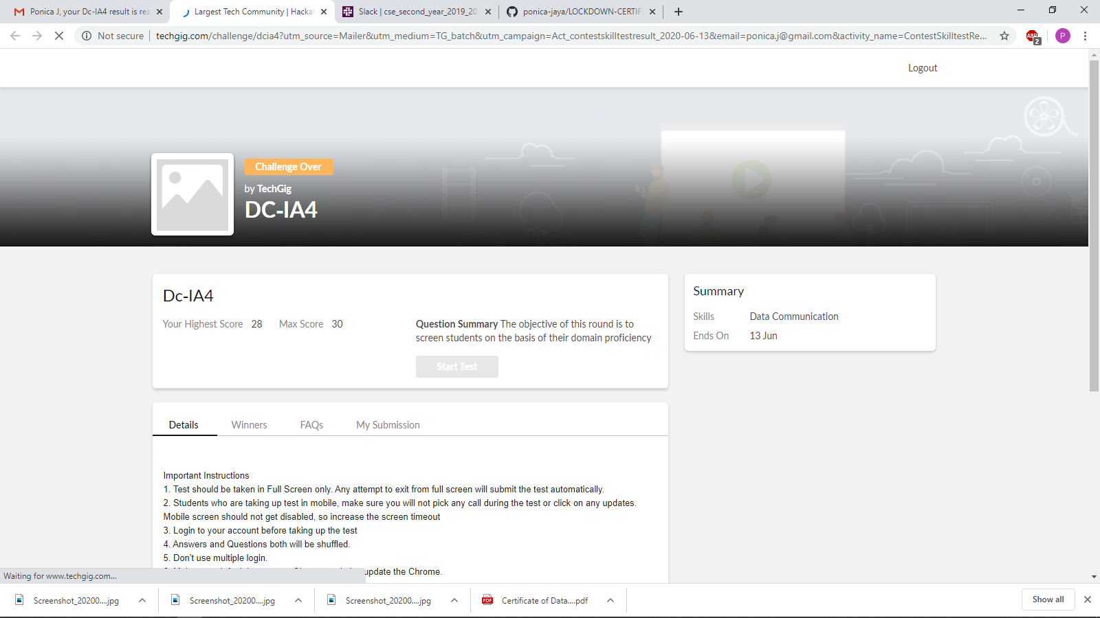

Certification Course Details: (Attach the snapshot and briefly write the report for the same)

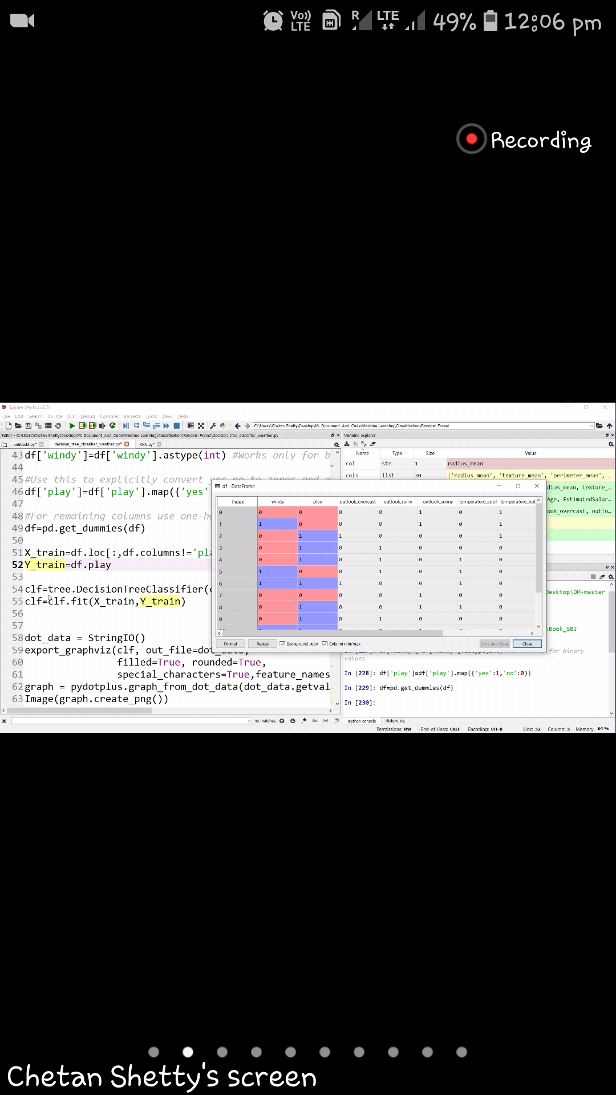

Coding Challenges Details: (Attach the snapshot and briefly write the report for the same)

I HAVE SOLVED TODAYS QUESTION AND THEN UPLOADED IN MY GITHUB ACCOUNT.

